Summary of 2025 Aphid Control in OH Leafy Green and Cucurbit Production
Ashley Leach and Arnol Gomez, OSU entomology (OARDC, Wooster, OH)
Objective
Evaluate the performance and timing of insecticides to control aphid populations in leafy greens and cucurbits. Specifically, this study aimed to:
- Quantify aphid densities and associated natural enemies across insecticide treatments.
- Compare the performance of selective and broad-spectrum insecticides when applied early versus late in the season.
OVERVIEW
Aphids emerged as a significant pest problem for Ohio vegetable growers in 2024. Outbreaks were most severe in August and September, when drought and heat stress favored aphid reproduction. High populations led to honeydew deposition, sooty mold development, and secondary fruit rot in several production fields. Preliminary observations indicated that use of broad-spectrum insecticides, such as Warrior II (λ-cyhalothrin), exacerbated aphid outbreaks, likely due to suppression of key natural enemies such as minute pirate bugs (Orius spp.), lady beetles, and parasitoid wasps. These findings highlighted a key management challenge: while pyrethroids remain affordable and effective against caterpillars and beetles, their use can unintentionally drive aphid resurgence. The trial was designed to evaluate both selective and broad-spectrum chemistries, and to develop practical programming recommendations for aphid management in Ohio vegetable production.
Location and Set-up
Field trials were conducted at the OSU Willard Muck Research Station in Willard, OH. The same design and plot layout used in previous insecticide efficacy work were implemented. Prior to the trial initiation, we consulted informally with Ohio vegetable growers and made some slight changes to our protocol to better reflect challenges with aphids in Ohio vegetable. First, instead of focusing on pepper, we switched to collard greens as many growers struggled with aphid outbreaks in leafy greens in 2024. Further, instead of using Harvanta (AI: cyclaniprole), we decided to substitute Exirel (AI: cyantraniliprole) as it is a more commonly used anthranilic diamide commonly used by Ohio growers, providing a more relevant comparison.
APHID INSECTICIDE TREATMENTS
A total of five insecticide products and an untreated control were evaluated for aphid management in two crops; Collard greens (‘Top Bunch’, Rupp Seeds) and summer squash (‘Reward’, Harris Moran Seeds). Trials were designed to implement treatments over two consecutive time periods (early and late season), allowing for comparison of product timing on aphid suppression. All treatments were applied weekly using a CO₂-pressurized R&D sprayer (four twin flat-fan nozzles, TJ-60 11003VS; TeeJet Technologies, Harrisburg, PA). Applications were made for 5 weeks per crop, corresponding to active aphid pressure.
Experimental Design
The experiment was arranged in a randomized complete block design (RCBD) with four replications per treatment (48 plots total across both crops). Early-season applications were conducted in May–June, and late-season applications in August–September. Insecticide treatments and rates are shown in the table below.
Table 1: Insecticide treatments to control aphids in collard greens and summer squash.
Product | Active Ingredient | Rate (oz/ac) | IRAC
Fufill | pymetrozine | 2.75 | 9B
Exirel | cyantraniliprole | 16.4 | 28
Beleaf | flonicamid | 2.8 | 29
Warrior II | Λ-cyhalothrin | 1.92 | 3
Actara | thiamethoxam | 3.0 | 4
Untreated Control |  |  | n/a
All treatments applied weekly for 5 weeks per crop using CO₂-pressurized R&D sprayer.
Seeding densities of crops varied, with 15 total plants in each zucchini plot and approximately 30-40 plants per plot. Ten central plants in each plot used for weekly scouting. Collard green plots were more dense Aphid populations were monitored visually on leaves, flowers, and developing fruit. Concurrently, natural enemies (minute pirate bugs, lady beetles, and syrphid larvae) were recorded from the same plants. Sticky cards were deployed biweekly to quantify flying predators and parasitoids.
Laboratory assay
We conducted a laboratory bioassay to evaluate the performance of natural enemies (lady beetles and minute pirate bugs) following exposure to insecticide leaf residues (Table 1). Leaves were collected from field plots 24 h after insecticide application and placed individually into Petri dishes. Natural enemies were confined on treated leaf tissue for 48 h, after which they were provided aphid prey. Aphid consumption was monitored for 72 h, and all prey consumed during this period were recorded. Total prey consumption was calculated as the proportion of aphids consumed relative to the total number of aphids provided over the duration of the assay. The assay was replicated twice for each natural enemy species.
Data Collection
Sampling began one week after initial treatment and continued through the end of each application window. Weekly counts were conducted to calculate the average:
- Number aphids per leaf
- Numbers of key predators (Orius spp., Coccinellidae, Syrphidae larvae).
Seasonal means were calculated for each treatment, and analyses will compare:
- Insecticide treatment effects (aphid and natural enemy abundance)

DATA SUMMARY
Aphid Populations in Field
While trials were seeded in June, all plots were ultimately terminated due to poor stands, precluding the inclusion of an early season planting to the data analysis. Nevertheless, our preliminary results from the second trial indicate that aphid densities were significantly lower in selective chemistries, particularly Beleaf, compared to the untreated control and Warrior II (Figure 1). As expected, the Warrior II plots experienced secondary aphid flare-ups approximately 1 week after application, suggesting a disruption of natural enemies rather than direct failure of aphid control. Differences were similar between crops, but Collards had fewer aphid outbreaks. Beleaf and Exirel were the only treatments that showcased significant differences in the collards compared to the untreated control. In the squash trial, we saw much higher populations of aphids. Warrior II had significantly more aphids than any other treatment and including the untreated control (Figure 1). Numerically, the best control was achieved with Beleaf, which maintained the lowest aphid densities (p < 0.05), followed by Fulfill and Exirel (Figure 1).
Natural Enemy Predation in Lab
Insecticide impacts on natural enemy performance largely followed expectations (Figure 2). Aphid predation was lowest when predators were exposed to Warrior II residues, indicating negative sublethal effects on predator feeding. In contrast, Beleaf had little to no impact on predation relative to the untreated control. Both predators exhibited similar responses to insecticide treatments; however, there were some small differences. Lady beetles and Orius spp. consumed high proportions of aphids in the untreated control, but Orius spp. showed a slightly higher sensitivity to insecticide exposure, particularly to Warrior II and Actara. Lady beetles maintained higher levels of aphid consumption across most treatments. Conversely, Exirel had minimal effects on Orius spp. but caused moderate reductions in lady beetle feeding, indicating taxon-specific responses to insecticide residues.
Natural Enemy Populations in Field
Lady beetles and Orius spp. were the dominant aphid predators observed in the field, accounting for approximately 90% of all natural enemies recorded. However, parasitized mummies were numerous across all treatments and crops, although parasitoids were rarely observed. Natural enemy populations generally tracked aphid densities (Figure 3). No significant differences in natural enemy abundance were detected among treatments in collards. In contrast, squash plots treated with Warrior II had significantly higher natural enemy counts, again likely driven by elevated aphid densities rather than enhanced predator conservation.
Recommendations from 2025 Findings
- Beleaf was the most reliable insecticide for aphid control across both collard greens and cucurbits.
- Exirel and Actara may be incorporated into rotations for resistance management, though efficacy was moderate compared to other treatments in the trial. However, both of these chemistries are broader in spectrum and may control other late-season target pests in the collard and zucchini systems.
- To conserve beneficial insects, alternate selective and broad-spectrum compounds and avoid blanket late-season applications, particularly when aphid populations are low.

Figures
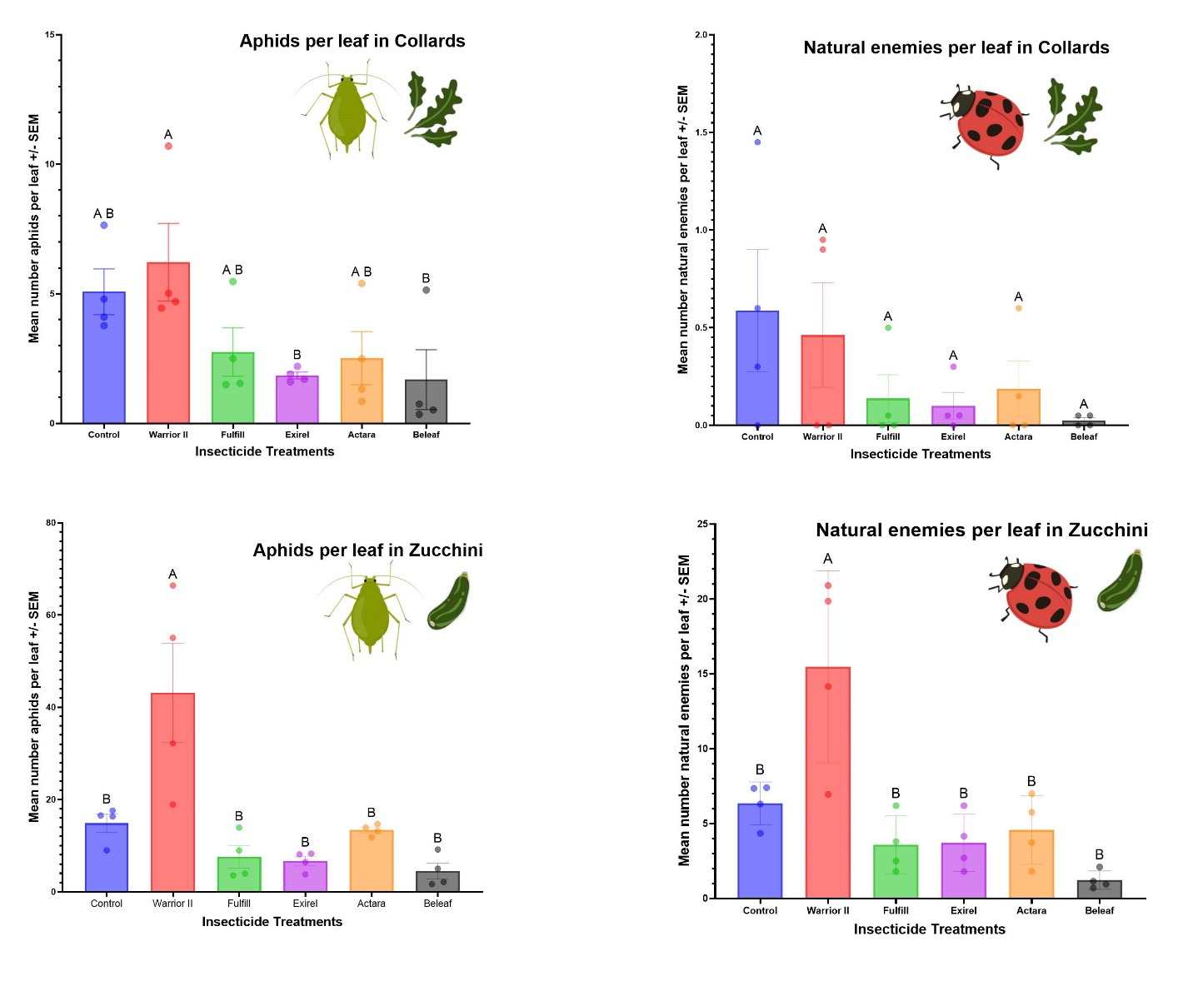
Figure 1. Insecticide trial results for aphid control and natural enemy abundance in collard greens and zucchini. Aphid densities (top left) and natural enemy abundance (top right) per insecticide treatment in collards (Aphid ANOVA: F [5,18] = 3.416, P = 0.0241; Natural Enemy ANOVA: F [5,18] = 1.430, P = 0.2611). Preliminary results of aphid densities (bottom left) and natural enemy abundance (bottom right) per insecticide treatment in squash (Aphid ANOVA: F [5,18] = 7.07, P = 0.0008; Natural Enemy ANOVA: F [5,18] = 10.74, P < 0.0001).

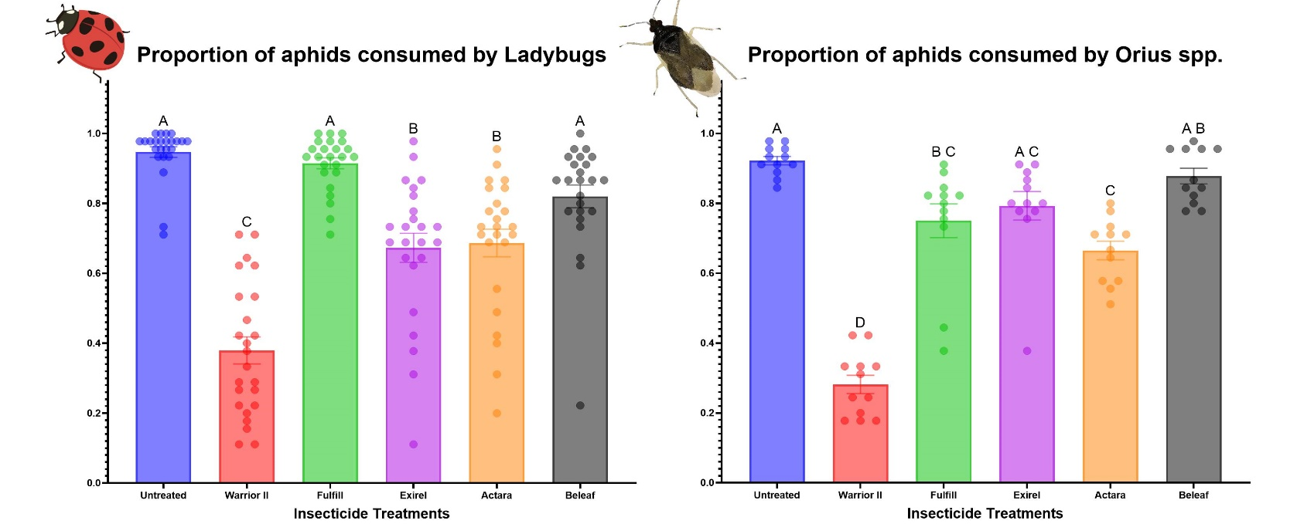
Figure 2. Aphid predation by two predators, Ladybugs (left) and Orius spp. (right) exposed to insecticide leaf residues. Warrior II resulted in the lowest predation for both predators.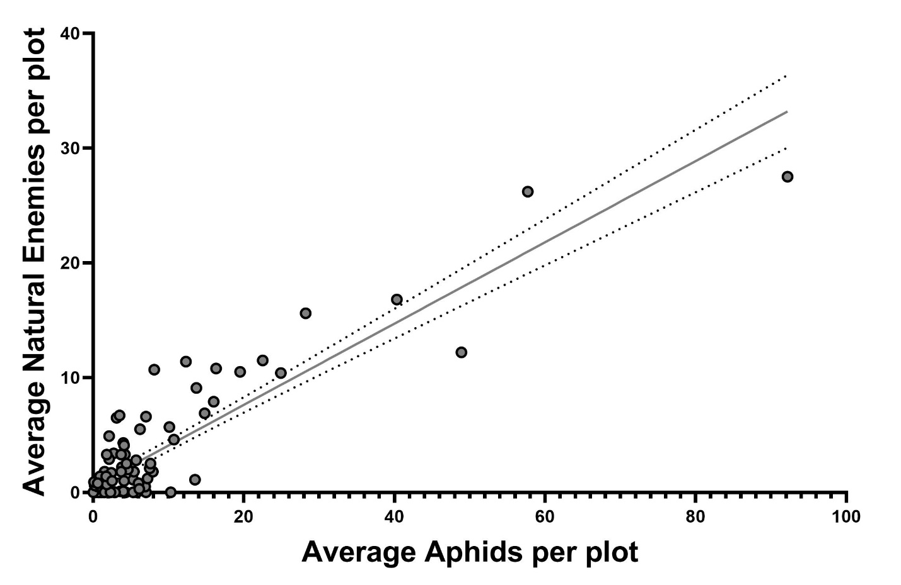
Figure 3. Positive significant relationship between Average aphids per plot and Average natural enemies per plot.

