Ohio Vegetable & Small Fruit Research & Development Program
Final Report 2025
Project Title:
Rapid and field-ready detection of soilborne pathogens using recombinase polymerase amplification
Principle Investigators: Andres Sanabria-Velazquez and Francesca Rotondo
E-mail: sanabria-velazquez.1@osu.edu rotondo.11@osu.edu
Other Key Personnel: Raven S. Schaffter (Research Technician)
Phone Number: 330-263-3721 (FR), 991-581-2905 (ASV)
Cooperating Institution: The Ohio State University
Mailing Address: Department of Plant Pathology, 1680 Madison Ave., Wooster, OH, 4469
Why was this project funded?
This project was funded to address a critical gap in the rapid and accurate detection of soilborne pathogens affecting Ohio’s vegetable industry. Diseases caused by Verticillium dahliae, Fusarium oxysporum, Root-knot nematodes, and other soilborne pathogens lead to significant yield and quality losses, yet their diagnosis currently depends on laboratory-based molecular tools that are time-consuming, require specialized equipment, and delay management decisions. Growers and consultants need an affordable, field-ready diagnostic method to confirm the presence of pathogens early in the season and guide immediate management actions. The proposed work integrates recombinase polymerase amplification (RPA), a portable, isothermal DNA amplification technique, with Whatman FTA cards for simple DNA collection and preservation from soil and plant samples. By validating RPA against conventional PCR under Ohio conditions, this project directly supports the development of rapid, reliable, and user-friendly diagnostic tools that empower growers, reduce disease spread, and strengthen the overall biosecurity and productivity of Ohio’s vegetable production systems.
Project outline
This project aims to develop and validate a rapid, field-ready diagnostic method for detecting major soilborne pathogens in Ohio vegetable systems using recombinase polymerase amplification (RPA) and Whatman FTA cards. The work involves designing and optimizing RPA assays for soilborne pathogens such as Fusarium oxysporum, and Root-knot nematodes evaluating FTA cards for simple field sampling and DNA preservation, and benchmarking RPA performance against conventional PCR to assess sensitivity, specificity, and reliability. The project will also integrate lateral-flow strips for easy, on-site visualization of results and conduct field testing in grower fields with known disease histories. The outcome will be a validated, low-cost diagnostic workflow capable of delivering accurate results in under 30 minutes, empowering growers and Extension personnel with faster, data-driven tools for soilborne disease management in Ohio.
Take-home messages
- The combination of RPA and Whatman FTA cards provides a fast, portable, and reliable method for detecting Meloidogyne spp. directly from infected tissue.
- The method eliminates the need for laboratory-based thermal cyclers and refrigeration, making it ideal for on-site diagnostics in fields, packinghouses, and inspection stations.
- RPA was up to ten times more sensitive than PCR, detecting as little as 0.0008 ng/µL of nematode DNA after 60 minutes of incubation.
- Lateral-flow strips allowed clear, visual detection of amplification results in under 30 minutes, simplifying interpretation for non-specialists.
- The workflow is safe, low-cost, and easy to use, enabling faster management decisions and reducing the risk of spreading regulated nematodes through contaminated planting material or shipments.
- Ongoing work is expanding this platform to detect soilborne fungi such as Fusarium oxysporum, aiming to develop a comprehensive, field-ready diagnostic toolkit for Ohio vegetable growers.
Impacts
This project advances rapid diagnostic capacity for soilborne pathogens that threaten Ohio’s vegetable industry. By integrating recombinase polymerase amplification (RPA) with Whatman FTA cards, we developed a portable workflow that eliminates the need for specialized equipment and cold storage, reducing diagnostic turnaround from several days to less than one hour. The method enhances on-site decision-making for growers, consultants, and inspectors, enabling faster containment of Meloidogyne spp. and reducing the risk of its spread through planting material or shipments.
Beyond nematodes, the ongoing expansion of this platform to Fusarium and other key soilborne pathogens will further strengthen Ohio’s plant health surveillance network. The resulting technology supports early detection, regulatory compliance, and sustainable disease management, while lowering costs associated with sample transport and laboratory processing. Ultimately, this work contributes to a more resilient and biosecure vegetable production system in the state.
What was discovered?
This project demonstrated that recombinase polymerase amplification (RPA), when paired with Whatman FTA cards, is a highly effective and sensitive method for detecting root-knot nematode (Meloidogyne spp.) directly from tissue. The RPA assay produced accurate results within 20–60 minutes at a constant temperature of 37 °C and showed up to tenfold higher sensitivity than conventional PCR, detecting DNA concentrations as low as 0.0008 ng/µL.
The use of FTA cards allowed safe, easy collection, transport, and storage of DNA without the need for refrigeration, making the workflow practical for field or packinghouse applications. The combination of RPA and lateral-flow strips enabled clear visual detection of results within minutes. These findings confirm that this approach can deliver rapid, field-deployable diagnostics for regulated nematodes and other soilborne pathogens. Ongoing work is adapting this same platform for the detection of Fusarium oxysporum, broadening its application for soil health and disease management in Ohio vegetable systems.
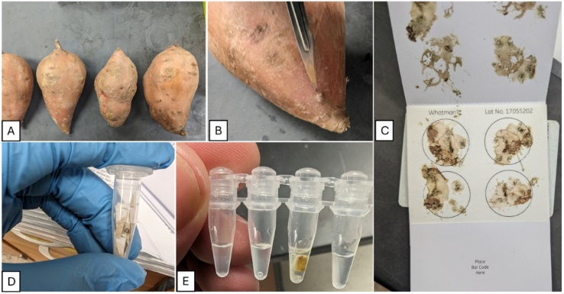
Figure 1. Whatman FTA cards were evaluated for effectiveness in Meloidogyne enterolobii DNA extraction directly from sweet potato galls. A: Sweet potatoes with visible galls after being washed under tap water for 1 min; B: The galled areas were excised using a scalpel; C: Whatman FTA cards with sweet potato gall tissue placed in the centre and hammered for 15 s. After 1 h, the solid plant tissue was removed; D: FTA paper cut into small pieces and placed into 1.5 ml tubes; E: Tubes containing FTA paper being used in PCR reactions (Adapted from Sanabria-Velazquez, A., Chowdhury, I.A., Sit, T.L. and Gorny, A.M., 2025. Recombinase polymerase amplification combined with FTA cards for detection of Meloidogyne enterolobii on sweet potato. Nematology, 27(7), pp.719-727.)

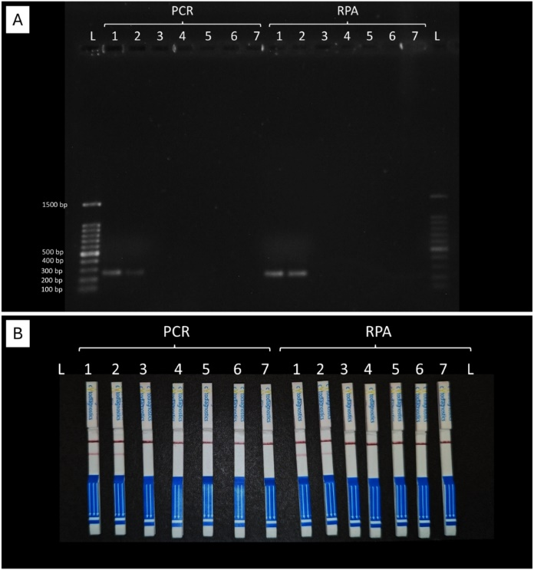
Figure 2. Comparison of PCR and RPA assays for Meloidogyne enterolobii detection. The experiment was repeated over two independent runs and results were identical. Therefore, only one experimental set is presented here. A: Gel electrophoresis analysis of amplification products from PCR (lanes 1-7) and RPA (lanes 1-7). Lane 1: M. enterolobii DNA from pure cultures, Lane 2: M. enterolobii DNA from Whatman FTA card, Lane 3: M. arenaria, Lane 4: M. hapla, Lane 5: M. javanica, Lane 6: M. incognita, Lane 7: negative control containing only autoclaved double distilled water. L: Ladder with size markers (100 bp to 1500 bp). The expected band size for the target gene is approximately 300 bp. Clear bands are visible in PCR lanes 1 and 2, and RPA lanes 1 and 2, indicating successful amplification of the target DNA; B: Lateral flow assay (LFA) strips used to visualise the amplification products from PCR (lanes 1-7) and RPA (lanes 1-7) following the same sample order. The appearance of a visible test line below the bold red control line indicates the presence of the target DNA amplicon. Consistent with the gel electrophoresis results, clear test lines are observed in PCR and RPA lanes 1 and 2, confirming successful detection of the target DNA. (Adapted from Sanabria-Velazquez, A., Chowdhury, I.A., Sit, T.L. and Gorny, A.M., 2025. Recombinase polymerase amplification combined with FTA cards for detection of Meloidogyne enterolobii on sweet potato. Nematology, 27(7), pp.719-727.)

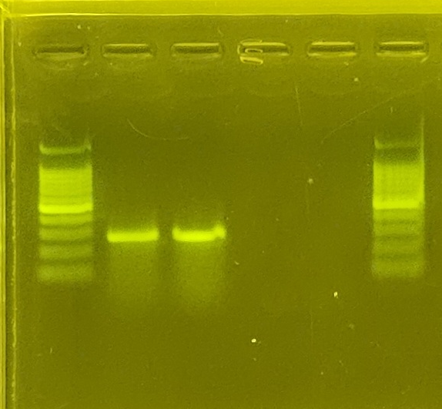Figure 3. Ongoing trials for Fusarium spp. Gel electrophoresis of recombinase polymerase amplification (RPA) products for the detection of Fusarium spp. Lane 1: DNA ladder (100 bp); Lane 2: Fusarium sp. DNA; Lane 3: Fusarium sp. DNA; Lanes 4–5: water (negative control); Lane 6: DNA ladder.

