Ohio Vegetable & Small Fruit Research & Development Program
Final Report 2025
Project Title:
Enhancing Disease Surveillance: Methods for Monitoring Cucurbit Downy Mildew
Principle Investigators: Andres Sanabria-Velazquez and Francesca Rotondo
E-mail: sanabria-velazquez.1@osu.edu rotondo.11@osu.edu
Other Key Personnel: Catherine Mwanjisi (Graduate Student), Raven S. Schaffter (Research Technician)
Phone Number: 330-263-3721 (FR), 991-581-2905 (ASV)
Cooperating Institution: The Ohio State University
Mailing Address: Department of Plant Pathology, 1680 Madison Ave., Wooster, OH, 4469
Why was this project funded?
This project was funded to address an urgent need for early detection and coordinated management of Cucurbit Downy Mildew (CDM) in Ohio. CDM, caused by Pseudoperonospora cubensis, is one of the most destructive foliar diseases of cucumbers, melons, squash, and pumpkins, capable of causing rapid yield losses once established. Historically, Ohio growers have relied on regional alerts from neighboring states like Michigan, often leading to delayed fungicide applications and preventable economic losses (Figure 1).
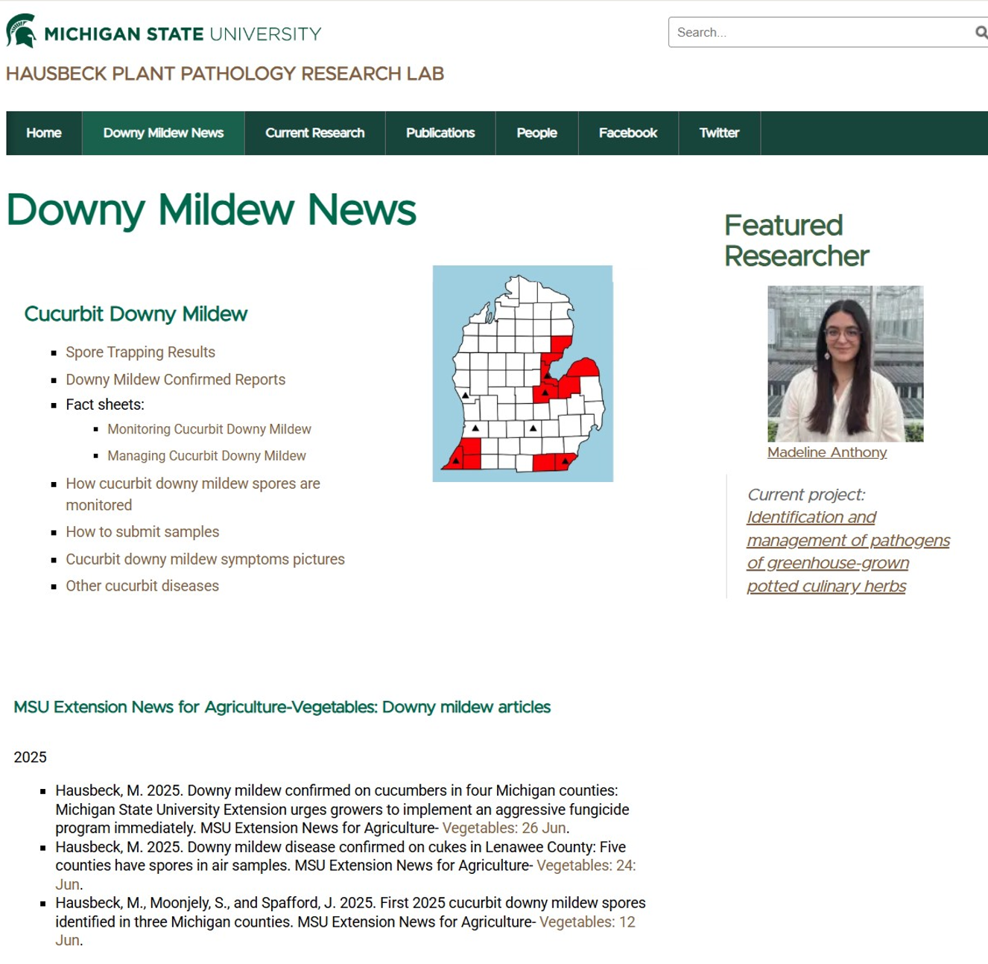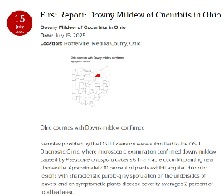
Figure 1. First detections of Cucurbit Downy Mildew (CDM) in the Great Lakes region during 2025. CDM was first reported in Michigan on June 26 and reached Ohio by July 15, confirming a northward movement of airborne inoculum. This pattern underscores the importance of local sentinel plots for early, state-specific alerts that enable timely fungicide applications and prevent unnecessary yield losses.
Many of the most effective fungicides against CDM can only be applied once or twice per growing season, according to label restrictions. This means that the timing of the first application is critical to disease control success. If fungicides are applied too early or too late, their protective window is wasted, leaving crops vulnerable to infection and accelerating resistance development.
By supporting this project, the funding source allowed initiation of a long-term statewide monitoring and early-warning system using sentinel plots and low-cost spore-trapping technologies. Early detection allows growers to apply fungicides precisely when the pathogen first appears, ensuring more effective disease suppression and optimized use of limited chemical options.
Project outline
Cucurbit Downy Mildew (CDM), caused by Pseudoperonospora cubensis, poses a recurring threat to Ohio’s cucurbit production. The disease spreads rapidly through airborne spores and can devastate fields within days once established. Because most effective fungicides can only be applied once or twice during the growing season, the timing of application is crucial. Early detection is therefore the cornerstone of effective management. Prior to this project, Ohio growers lacked a coordinated system for local CDM monitoring and early warnings, depending instead on regional alerts from other states.
Objectives
- Establish sentinel plots across major cucurbit-producing regions in Ohio to monitor the onset and progression of CDM.
- Implement and validate low-cost spore-trapping methods for early pathogen detection.
- Integrate field and diagnostic data into an early-warning and communication system for timely grower alerts.
- Disseminate outcomes through extension networks, meetings, and grower-friendly bulletins.
Methods
Sentinel plots were installed at four OSU research sites (Fremont, Willard, Wooster, and Piketon) representing diverse production environments. Each plot included multiple cucurbit hosts (cucumber, melon, squash, pumpkin, and watermelon) surrounded by guard rows to minimize edge effects.
Weekly scouting was conducted for visual symptoms, complemented by airborne spore collection using Burkard volumetric samplers and low-cost rotating-arm traps. Suspect samples were submitted to the C.W. Ellett Plant and Pest Diagnostic Clinic for confirmation by microscopy and molecular assays. Once confirmed, disease reports were shared through OSU Extension and CDM ipmPIPE to inform statewide management decisions.
Take-home messages
- Cucurbit Downy Mildew (CDM) remains a major threat to Ohio’s cucurbit industry, capable of destroying crops within days once infection occurs.
- Early detection is the single most critical factor for successful management — many of the most effective fungicides can only be applied once or twice per season, making application timing essential.
- Sentinel plots and low-cost spore traps proved effective tools for early warning, often detecting airborne spores before visible symptoms appeared in the field.
- Statewide coordination between research, diagnostics, and extension allowed rapid confirmation and communication of CDM detections, giving growers actionable time to protect their crops.
- Integrated management works best: combining cultural practices, resistant varieties, and targeted fungicide use reduces disease pressure and prolongs fungicide efficacy.
- Grower participation and information sharing are key to sustaining this monitoring network and expanding it into a predictive forecasting system for future seasons.
- Continued investment in surveillance, modeling, and outreach will strengthen Ohio’s capacity to respond proactively to CDM and other airborne plant pathogens.

Impacts
This project lays the foundation for a statewide disease forecasting system that links sentinel plots, spore traps, and diagnostic networks to real-time decision tools. Such a system will empower Ohio’s specialty crop industry with data-driven, sustainable pest management strategies and reduce losses caused by late disease detection. In addition, Graduate students and field staff received hands-on training in airborne spore monitoring, molecular diagnostics, and disease scouting, strengthening Ohio’s applied plant pathology workforce. Results were shared through VegNet newsletters, grower field days, and regional meetings, improving disease awareness and engagement with early-warning systems
What was discovered?
- Cucurbit Downy Mildew (CDM) reached Ohio about three weeks after its first detection in Michigan. In 2025, the first CDM report occurred in Michigan on June 26, while Ohio’s first confirmed detection was on July 15 (Figure 1). This northward movement highlights the progressive, regional spread of airborne inoculum and demonstrates why local sentinel plots are essential for providing timely, state-specific alerts. Without in-state monitoring, Ohio growers would have had to rely solely on regional forecasts, which can underestimate local infection timing and lead to delayed fungicide applications.
- Subsequently confirmed detections were made in Sandusky, Holmes, and Ashland counties by July 24 (2025).
- Detection was achieved through a combination of sentinel plot scouting and airborne spore monitoring (Burkard volumetric samplers and low-cost rotating-arm traps, Figure 2).
- Microscopy and DNA-based assays confirmed the presence of Pseudoperonospora cubensis spores from trap samples and symptomatic leaf tissue.
- Early-season spore detections occurred before visual symptoms in some sites, showing the potential of spore traps as an early-warning tool for growers.
- Extension alerts were issued immediately after confirmation, helping growers initiate timely fungicide programs.

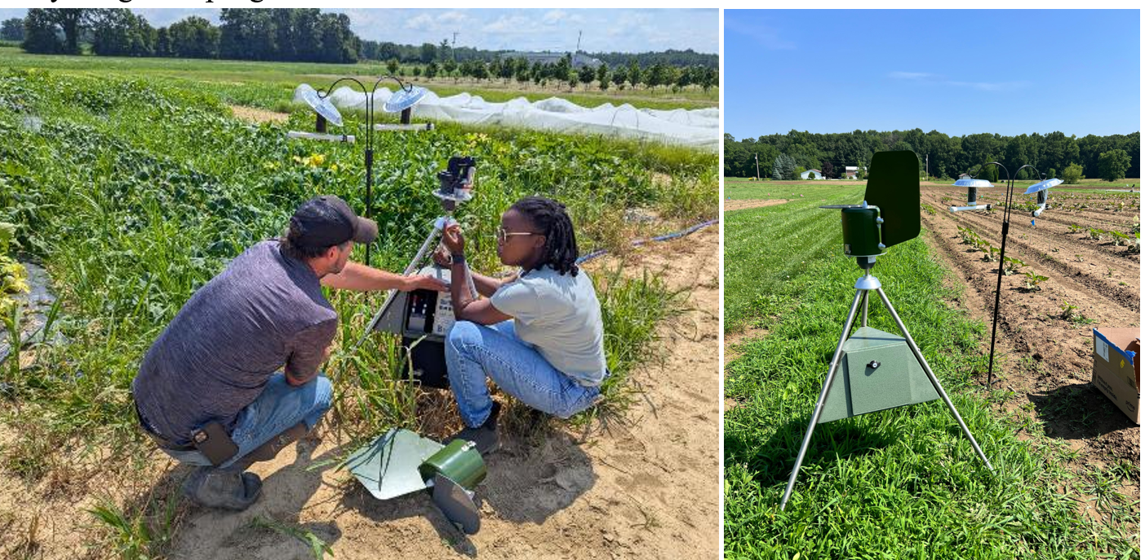Figure 2. Deployment of spore traps in sentinel plots for Cucurbit Downy Mildew monitoring in Ohio (2025). Field teams installed and evaluated multiple spore-trap models, including volumetric and low-cost rotating-arm designs, to develop affordable early-detection systems for airborne pathogens. These tools support timely disease alerts and improve local monitoring capacity across Ohio’s vegetable production regions.

