Summary of 2024 Thrips control in OH pepper production

Ashley Leach and Arnold Gomez, OSU entomology (OARDC, Wooster, OH)

**Objective:** **Quantify thrips** infestation in different insecticide treatments and assess overall impact of insecticide treatments on **natural enemy populations** to control thrips populations on bell peppers.

**Overview:** Thrips are a common pest in pepper production, where unchecked outbreaks can lead to stunted, deformed or russeted fruit. High infestations early in the season can also compromise plant growth and lead to larger populations during harvest thus leading to marred fruit. Choosing the right product can make the difference between blowing up a population or keeping a population below threshold injury levels. Certain broad-spectrum compounds can also compromise natural enemy populations, leading to increased secondary pest outbreaks. In the case of Midwest pepper production, thrips populations can be effectively reduced by natural enemies like minute pirate bugs, lady bird beetles and lacewing larvae. Thus, the goal of this project is to determine best products to control thrips outbreaks in peppers.*In total, we tested 6 insecticide products in a randomized field trial using Bell pepper, ‘Aristotle’.*

**Location:** Fremont, OH [OSU North Central Agricultural Research Station]

**THRIPS INSECTICIDE TRTS:** Trial was conducted comparing control of thrips with 1) Plinazolin (2.0 oz/ac), 2) Exirel (20.0 oz/ac), 3) Radiant (10.0 oz/ac), 4) Movento (5.0 oz/ac), 5) Warrior II (1.92 oz/ac), 6) Admire Pro (1.3 oz/ac), and 7) untreated control.

**Experimental set up (same as 2023 set up):** A total of 6 insecticide products was tested for control of thrips in pepper production (shown above). Due to the differing susceptibility of pepper cultivar to thrips feeding, we conducted insecticide trials in a sweet “Bell” pepper type (‘Aristotle’). To test the efficacy of these treatments, each insecticide was applied 6 times consecutively (=6 weeks of data collection). The trial was organized in a RCBD with four replications per treatment including the untreated control (=56 plots total) (Fig 1). Insecticides were applied weekly using a CO2-pressurized R&D sprayer with four, twin flat-fan nozzles (TJ-60 11003VS; TeeJet Technologies Harrisburg, PA). The thrips trial ran for 8 weeks beginning in July and ending in August.

**Data collection:** Eight plants per plot were scouted weekly for the presence of thrips on leaf tissue and flowers (n= 8 plants per plot* 4 replicates= 32 plants per treatment per week). Minute pirate bugs were counted on flowers every week while counting thrips populations. Occasionally, lady beetles were observed in the peppers (<~5% of samples). However, minute pirate bugs were the most prevalent thrips natural enemy observed in the trial. Seasonal mean thrips per flower will be reported as a proxy for thrips control (Fig. 2). Similarly, season mean minute pirate bugs are reported as proxy for biological control (Fig. 3). Marketable yield is not reported due to a high level of anthracnose that interfered with marketable yield assessment of thrips feeding on fruit.

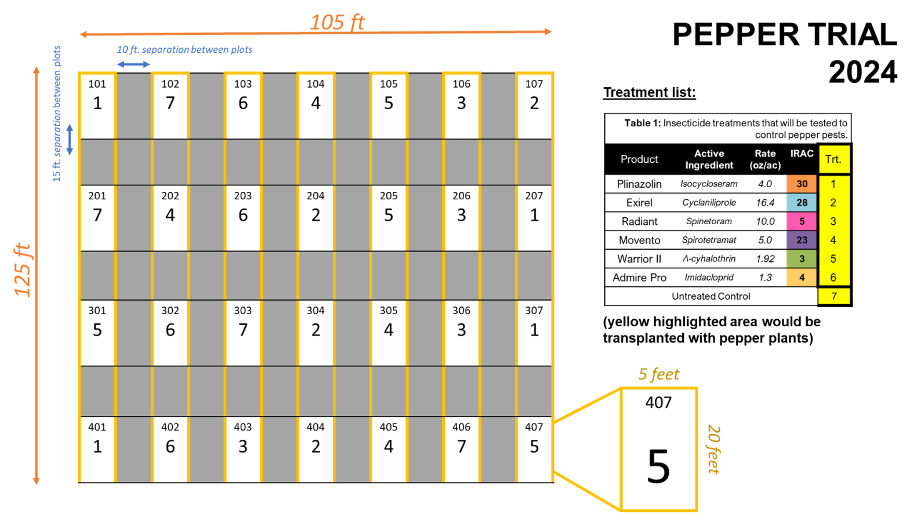

*Figure 1: 2024 Experimental set up and design that tested 6 different insecticide products and an untreated control on thrips control in pepper production.*

**DATA SUMMARY:**

**Thrips populations.** Thrips densities were generally low in 2024, however significant trends were noted. (Fig.2). Untreated controls and ‘Movento’ had the highest numbers of thrips. Lowest thrips numbers were in ‘Radiant’ which meets expectations as it is typically the best “knock-down” product for thrips control in vegetable production. All other compounds (Exirel, Warrior II, Admire Pro and Plinazolin) performed well but were not significantly different from the untreated control or Movento. Seasonally, thrips populations were the highest later in the season (second week of July ~07/17-07/26) when populations peaked at ~2 thrips per flower. Thrips populations quickly peaked during mid-July to early August and then decreased to <0.5 thrips per flower. None of the values, even the untreated control, reached threshold levels (6 thrips per flower). However, previous study by Leach and Gomez indicate that lower thresholds are likely better for OH pepper production (~2-3 thrips per flower).

● Recommendation from these findings: **Radiant performed best** and should be used when facing thrips outbreaks in pepper production. However, *stewardship of Radiant is key* and the product should be rotated with other insecticides to reduce the likelihood of insecticide resistance development. Movento needs further refinement, it appears that this compound may perform well early in the season when the population is building but does not control adults.

 *Figure 2: Seasonal thrips densities (+/- SE) in 6 different insecticide programs applied consecutively over six weeks in 2024. Trial was conducted with Bell pepper, ‘Aristotle’.*

**Minute Pirate Bug Populations.** Minute Pirate Bugs (Orius *spp.*) are **excellent thrips predators**. One Minute Pirate Bugs can kill 40 thrips. Conserving these populations can make a big difference in the efficacy of thrips control in pepper production. High populations of Minute Pirate Bugs were noted in insecticide treatments, ‘Exirel’ and ‘Movento’. In both cases, these values were statistically similar to the untreated control. Concerningly, Warrior II had low levels of Minute Pirate Bugs and poor control of thrips (fig.2). Thus, **we caution the use of Warrior II** in pepper production as it may increase the likelihood of secondary pests like thrips. As an aside, the Warrior II treatment was also 24 times more likely to experience an aphid outbreak as compared to any of the other treatments. Radiant has lower numbers of Minute Pirate Bugs, however we attribute this to a lower prey availability due to the product’s greater ability to control thrips (Fig. 2).

● Recommendation from these findings: If trying to conserve natural enemies that will lower thrips populations, **use** **Warrior II sparingly.** Pyrethroids should be carefully used as they may increase the number of pest problems faced by Midwest pepper growers.

*Figure 3: Seasonal minute pirate bug densities (+/- SE) in 6 different insecticide programs applied consecutively over six weeks in 2024. Trial was conducted with Bell pepper, ‘Aristotle’.*

**Marketable Yield.** Due to the high level of sun scald and anthracnose, we were unable to discern if there was any thrips feeding on the fruit. **No significance differences** in yield were observed in the marketable weights per plot.