**Ohio Vegetable & Small Fruit Research & Development Program**

**Final Report**

**2023**

**Project Title:** Vegetable and Fruit Disease Diagnosis

**Principle Investigator(s)**: Francesca Rotondo, Melanie Lewis Ivey, and Sally Miller

**Phone Number**: 330-263-3721 (FR), 330-263-3849 (MLI), 330-263-3678 (SAM),

**Fax**: 330-263-3841

**E-mail**: rotondo.11@osu.edu ; [ivey.14@osu.edu](mailto:ivey.14@osu.edu): [miller.769@osu.edu](mailto:miller.769@osu.edu)

**Cooperating Institution**: The Ohio State University, CFAES Wooster Campus, Department of Plant Pathology

**Mailing Address**: 1680 Madison Ave., Wooster, OH 44691

**Other Key Personnel**: Vansh Khatri summer student, Shane Allan Research Associate (PPDC OSU) - The Ohio State University, CFAES Wooster Campus

**Why was this project funded?** This diagnostics project is primarily a service to commercial vegetable and fruit growers in Ohio. We request funding each year to help support OSU Vegetable and Fruit Pathology Laboratory efforts to assist growers in diagnosing crop diseases, particularly in the case of unusual or difficult-to-diagnose cases and diseases that have explosive potential and require early detection on a regional scale.

**Project outline**. As every year, we used traditional and modern, state-of-the-art diagnostic methods. These include light microscopy to identify fungal and oomycete (Phytophthora, Pythium, downy mildew) pathogens based on morphology, culturing followed by microscopic or other identification, biochemical and plant tests for bacterial identification, serological assays, mainly for virus and bacterial identification, specific polymerase chain reaction (PCR and quantitative PCR foe detecting low inoculum of *Xanthomonas* spp. affecting tomato and pepper an *Clavibacter michiganensis*) assays and genomic sequencing. This year we have add molecular testing foe Fusarium wilt and Verticillium wilt. The diagnostic lab is also implementing fungicide resistance screening for *Colletotrichum* spp. (anthracnose) as a service to offer to the growers.

The digital diagnostic is a tool that has showed its importance during the pandemic era, and it is still a valid tool for a prompt communication with growers, crop consultants and extension educators. Digital sample submission was performed through email, diagnostic website, and phone text messages. Physical samples were received by mail or in-person drop off by the growers, crop consultants and extension educators. After initial evaluation, the submitter was contacted within 24 hours by phone or email and provided with a preliminary diagnosis and management recommendations. In many cases this was also the final diagnosis. If culturing or other time-consuming tests were required, final results may not have been available for several days to one week.

**Take-home messages** This year we had an extremely hot and dry summer that has created a less conducive environment for plant pathogens and disease development. The findings from the diagnostic clinic were shared with the growers directly and through our blogs and Tweets: VeggieDisease.News blog (u.osu.edu/miller.769), the VegNet Newsletter (vegnet.osu.edu), Twitter (@OhioVeggieDoc and @OHFruitPathology), Ohio Fruit News (OFN; <https://u.osu.edu/fruitpathology/fruit-news-2/>), the fruit pathology Facebook page (@fruitpathology), the Ohio Grape IPM Facebook page (@ohiograpeipm), and directly to county Extension educators. The sources (grower name, address) of the diagnostic samples are never revealed to the public. Grower communication in 2023 was predominantly through emails, phone calls, and in-person communication. Relevant issue were highlighted on social media platforms, websites and in newsletters. This year we attended crop walks, in-person field days and on-farm visits. We carried on in-person trainings, zoom meetings and webinars. Cut flowers and ornamentals are confirmed as a popular commodity for many growers in Ohio.

**Impacts.**

In 2023, we diagnosed a total of 339 samples. The estimated cost of providing the basic service to growers, considering labor and supplies, is $70 per physical sample. This does not include the cost of advanced diagnostics necessary in some cases or overhead costs. We estimate that the cost of diagnosing electronic samples is $20/sample. Therefore, the value of this service in 2023 to Ohio fruit and vegetable growers is at least $21,450. ***This represents a 3.7:1 return on grower’s investment in this project.***

|  |  |  |  |  |
| --- | --- | --- | --- | --- |
| **Sample Type** | **Commodity** | | | **Estimated Value ($)** |
|  | **Vegetable** | **Fruit** | **Ornamental**  **Cut flowers** |  |
| Physical | 186 | 75 | 30 | $20,370 |
| Electronic | 30 | 20 | 4 | $1,080 |
| **Total** | **216** | **95** | **34** | **$21,450** |

**What was discovered?**

In hydroponic greens production, *Pythium dissotocum* (group B2) and P*ythium aphanidermatum* continue to be important pathogens that significantly impact yields in this type of production.

For both tomatoes and peppers, bacterial spot was the most frequently diagnosed. Fusarium wilt continue to be a problem in both tomatoes and peppers. Phytophthora blight was often reported in both pepper and cucurbits in the late summer.

At the beginning of the field season, we received many samples showing abiotic disorders (mostly drought stress) and nutrient deficiency. Herbicide/chemical damage continues to be an issue on vegetable crops.

Tomato spotted wilt virus (TSWV; Tospovirus) was diagnosed in tomatoes.

For vine crops, we pinpointed the first appearance of downy mildew in cucumbers, melons, pumpkins and squash in 4 counties in the state. All first reports were submitted to the multistate cucurbit downy mildew forecasting site (Cucurbit ipmPIPE; <http://cdm.ipmpipe.org/>). Downy mildew was also reported on basil in Wayne County. This year downy mildew in cucurbits appeared in early July. Downy mildew and powdery mildew were the most frequently reported diseases among cucurbits.

For fruit diagnostic, anthracnose and Phytophthora crown rot on strawberry were often diagnosed on strawberry. Neopestalotiopsis disease was also diagnosed in October on strawberry. Currently, fungicide sensitivity studies are ongoing to expand our knowledge for an effective disease management of anthracnose and Neopestalotiopsis disease.

Ripe rot on grape berries, caused by Colletotrichum spp., was diagnosed at the end of the growin

**A. Vegetable Diagnostics Report**

A total of 216 samples (186 physical and 30 electronic) were diagnosed in 2023. The majority of the samples were submitted by or on behalf of commercial vegetable producers in Ohio (Figure 1).

|  |
| --- |
|  |
| **Figure 1.** Sources of vegetable samples submitted to the OSU Diagnostic Clinic during 2022. |

Vegetable samples were received from 30 Ohio counties, three samples were received from out of State (from Indiana, Michigan and Wisconsin Figure 2). The highest number of samples were submitted from Wayne County (N= 37), Huron County (N=19), and Sandusky (N=18). The samples from Wayne County were mainly collected by OSU Wayne County Extension IPM Scouting educators, while the samples from Huron county were in collaboration with the Muck Crops Agricultural Research Station in Willard and the ones from Sandusky were in collaboration with the North Central Agricultural Research Station in Fremont. Holmes, Washington, Belmont Columbiana, Hamilton and Butler were the other counties that have submitted between 5 and 10 samples.

**Figure 2.** Map of the counties that submitted vegetable samples for diagnosis to the OSU Diagnostic Clinic.

Most of the samples received were solanaceous crops (tomatoes, peppers, eggplant and potatoes) followed by cucurbits (cucumbers, melons, watermelon, zucchini, squash and pumpkins) (Figure 3). Among the solanaceous crops tomatoes were the most frequently received followed by peppers (Table 1), while among the cucurbitaceous crops, cucumbers were predominant (Table 2). The remaining samples included cole crops (Table 3), leafy greens, herbs, and Alliaceae. The“others” category included legumes, rhubarb, tomatillo, carrots, dandelions and okra. Among the onion sample bacterial soft rot was the most frequently diagnosed disease. Bulb mites were diagnosed on garlic, and the carrot samples had Alternaria leaf blight. Herbs (parsley, dill and basil) were diagnosed with Fusarium wilt, Pythium root rot and downy mildew, respectively.

Many vegetable farms in the State have started cut flowers and ornamental cultivation as new source of profit. We received a total of 18 ornamental/cut-flower samples. For this commodity, diseases caused by fungal root rot (Pythium root rot, Phytophthora root rot, and Rhizoctonia root rot) were the major issue. Mite and aphid infestations were also an important problem. These pests are favored by the dry and hot weather.

The cut flowers were diagnosed with mite damage, bacterial blight, Rhizoctonia root rot, Phytophthora root rot and abiotic disorders (nutritional, herbicide damage).

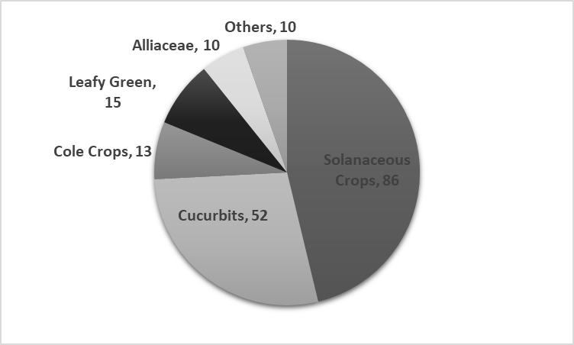

**Figure 3.** Number of vegetable samples received for diagnosis by the OSU Diagnostic Clinic in 2022.

**Table1**. Diseases, pests and abiotic disorders diagnosed on solanaceous crops

|  |  |  |  |  |
| --- | --- | --- | --- | --- |
| **Solanaceous crops**  **(N samples)** | **Diagnosis** | | **County** | |
| Tomato (55) | | Bacterial spot, Bacterial canker, Gray Mold, Leaf Mold, Septoria Leaf Spot, Early Blight, White Mold, Anthracnose, Fusarium Wilt, Tomato Chlorotic Spot Virus, Tomato Spotted Wilt Virus, Abiotic (blossom end rot, Catface, Zippering Edema) | | Belmont, Columbiana, Sandusky, Washington, Adams, Holmes | |
| Pepper (25) | | Anthracnose, Bacterial Spot, Fusarium Wilt, White Mold, Phytophthora Blight, Spray damage, Herbicide damage, Broad mites, Blossom End Rot | | Belmont. Columbiana, Holmes, Huron, Sandusky, Summit, Wayne | |
| Eggplant (3) | | Alternaria Leaf Spot, Verticillium Wilt | | Huron, Wayne | |
| Potato (3) | | Soft Rot, Potato scab | | Lorain, Perry | |

**Table 2**. Diseases, pests and abiotic disorders diagnosed on cucurbits

|  |  |  |
| --- | --- | --- |
| **Cucurbits**  **(N samples)** | **Diagnosis** | **County** |
| Cucumber (15) | Downy mildew, Fusarium wilt, Angular leaf spot | Medina, Wayne, Holmes, Sandusky |
| Squash /Zucchini (20) | Powdery mildew, Bacterial wilt. Bacterial leaf spot | Wayne, Holmes, Sandusky |
| Pumpkin (15) | Bacterial leaf spot. Phytophthora Blight, Cucurbit Yellow Vine Decline, Abiotic (drought, heat), Powdery mildew | Huron, Wayne, Holmes, Sandusky |
| Watermelon (2) | Cucurbit Yellow Vine Decline (suspected) | Franklin |
|  |  |  |

**Table 3.** Diseases, pests and abiotic disorders diagnosed on cole crops

|  |  |  |
| --- | --- | --- |
| **Cruciferous crops**  **(N samples)** | **Diagnosis** | **County** |
| Cabbage (8) | Black Rot, Nutritional, Insect Damage, Rhizoctonia Wirestem, Soft Rot | Sandusky, Huron, Wayne, Richland |
| Collard (2) | Nutritional, Spray Damage | Huron, Perry |
| Broccoli (1) | Alternaria leaf spot | Sandusky |
| Chard (2) | Spray damage, Bacterial leaf spot | Richland, Knox |

**B. Diagnostics Fruit Report**

Ninety-five fruit samples (75 physical and 20 electronic) samples were received for diagnosis (Table 1).

The majority of the samples were small fruit (strawberry, blackberry, raspberry, elderberry, blueberry and currant), while the remaining were tree fruit (pome fruit and stone fruit), nut tree (walnut and chestnut) and grape (Figure 4). Samples were received from 25 counties in Ohio (Figure 5). The majority of the samples were submitted by commercial growers and extension educators (Figure 6)

Fungal diseases were predominant, followed by abiotic injuries, (mostly chemical damage and nutrient deficiency), and insect related injuries (Table 4).

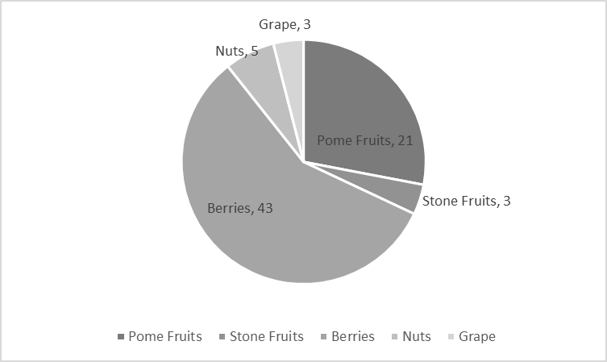

**Figure 4.** Number of fruit samples received for diagnosis by the OSU Diagnostic Clinic in 2022.

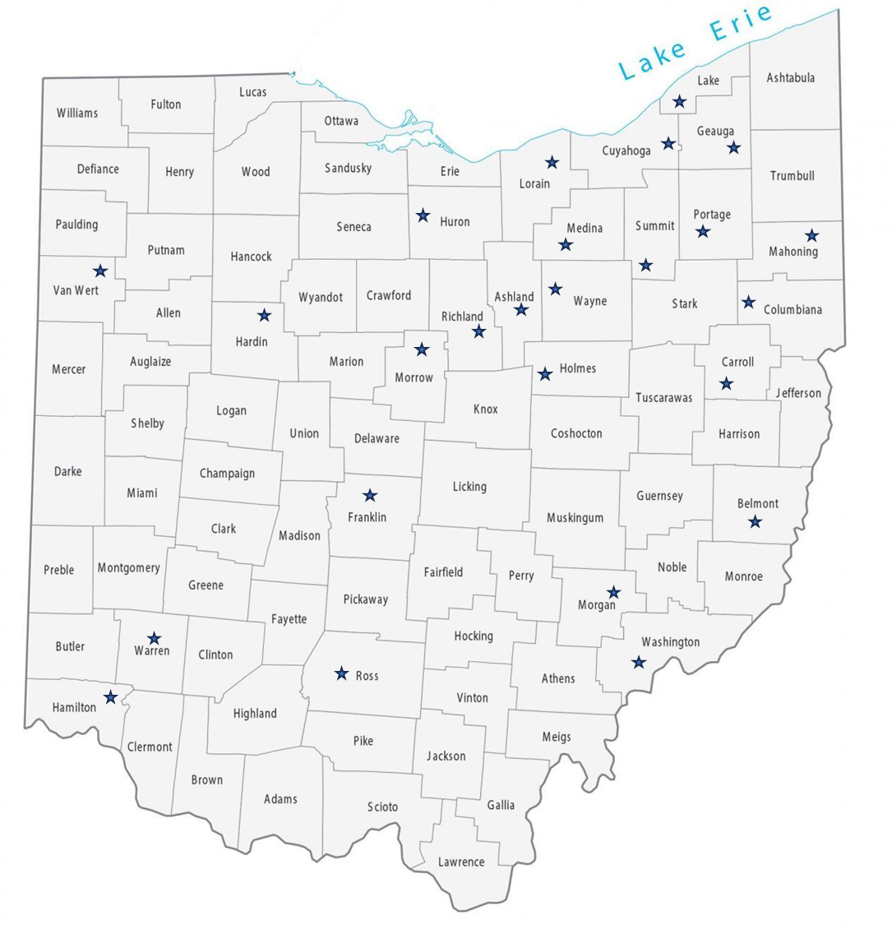

**Figure 5.** Map of the counties that submitted fruit samples for diagnosis to the OSU Diagnostic Clinic.

**Figure 6.** Sources of fruit samples submitted to the OSU Diagnostic Clinic during 2022.

|  |  |  |
| --- | --- | --- |
| **Crop (N samples)** | **Diagnosis** | **County** |
| Strawberry (20) | Anthracnose, Phytophthora root rot, Black root rot, Leaf scorch, Neopestalotiopsis disease, Nutritional, Cold damage | Columbiana, Greene, Wayne, Holmes, Portage, Washington, Richland, Van Wert, Geauga, Morrow, Summit, Hamilton, Ross |
| Blueberry (6) | Phytoplasma, Phytophthora root rot, abiotic | Warren, Mahoning, Wayne, Lake |
| Raspberry (4) | Glyphosate damage, Nutritional | Wayne, Summit, Hardin |
| Elderberry (2) | No pathogen detected | Athens |
| Blackberry (3) | Blackberry wasp gall, Abiotic | Columbiana, Warren |
| Currant (3) | Cane blight | Lake |
| Apple (16) | Bitter rot, White Rot, Plum Curculio, Abiotic (temperature related) Fire blight | Wayne, Medina, Holmes |
| Pear (5) | Fire blight, Cicada damage Entomosporium fruit blotch, Pear rust | Cuyahoga, Columbiana, Morgan |
| Plum (2) | Abiotic, Alternaria leaf spot | Wayne |
| Peach (1) | Powdery mildew | Wayne |
| Grape (3) | Ripe rot, abiotic | Wayne, Belmont |
| Walnut (2) | Anthracnose | Franklin |
| Chestnut (3) | Oak wilt, Diplodia canker | Carroll |