Ohio Vegetable & Small Fruit Research & Development Program
Final Report
2023

Project Title: Seed and Seedling Treatments to Manage Bacterial Spot in Peppers- Part (2)
Principle Investigator(s): Sally A. Miller and Francesca Rotondo
Other Key Personnel: Vansh Khatri

Phone Number: 330-466-5249 (mobile)

Fax: 330-263-3841

E-mail: miller.769@osu.edu; rotondo.11@osu.edu

Cooperating Institution: The Ohio State University

Mailing Address: Department of Plant Pathology, 1680 Madison Ave., Wooster, OH 44691

Why was this project funded? We have data from previous work supported by OPGMA that biological products can help in reducing the disease incidence and severity of bacterial diseases on pepper, when applied as a seed treatment and/or foliar spray. In the experiment carried out in 2022, Regalia, Howler and Theia significantly reduced bacterial spot disease incidence by 55%, 48% and 45%, respectively, compared to the non-treated control when applied as a seed treatment on artificially infested seeds. For this reason, we wanted to further explore the efficacy of biologicals against bacterial leaf spot on pepper.

Project outline:
The efficacy of the biological products (Serenade ASO, Serifel, LifeGard WG, Stargus, Regalia, Brandt Organics Aleo, Theia, Double Nickel and Howler) against bacterial leaf spot was tested on artificially infested pepper seeds (cultivar organic Muscato F1). Seeds were artificially infested with a bacterial suspension (10¹⁰ CFU/ml ) of Xanthomonas euvesicatoria (Xe) strain SM215-20. Hot water-treated seeds served as a commercial standard, while non-treated seeds were used as negative control.
The application rate for Serenade ASO, Serifel, LifeGard WG, Stargus, Brandt Organics Aleo, Theia, and Double Nickel was 10⁹ CFU per gram of seed, while Regalia was applied as a 1:1 ratio product:water, and Howler was applied at 10⁶ CFU/gram of seed. Seeds and treatments were placed in 50 ml sterile Falcon tubes and gently shaken for 20 minutes at room temperature on a shaker. To ensure that the all the seeds were in contact with the treatments, the Falcon tubes were hand agitated every five minutes. Before planting, seeds were dried overnight in a laminar flow hood. Seeds were planted in 98-cell flats filled with Baccto potting soil mix in a greenhouse (completely randomized block design) in Selby Hall, CFAES Wooster Campus. Plants were monitored daily for symptoms.
A third round of experiments was conducted in November-December to evaluate the efficacy of the biologicals against Pseudomonas syringae pv. syringae (Pss) and Clavibacter michiganensis (Cm). Two separate batches of organic Muscato F1 pepper seeds were artificially inoculated the Pss strain SM155-2019 and Cm C290, as previously described. After inoculation the infested seeds were treated with biologicals following the same protocol use for the Xe trials.
Take-home messages: We confirmed the efficacy of biologicals to suppress bacterial leaf spot on pepper when applied as a seed treatment to non-coated and/or non-treated pepper seeds. Seedlings grown from seeds treated with hot water showed the lowest values for disease incidence and severity in both trials and hot water remains the most effective treatment for bacterial seedborne disease control. The trial carried out in November December against Pseudomonas leaf spot produced similar results with the hot water treated seeds showing the lowest disease incidence values. Seedlings originated from Cm infested seeds did not show any disease symptoms in any of the treatments (including the non-treated control). This suggests that the bacterial strain might have lost its viability during the infestation process.
Impacts: This research project confirmed the potential of biological products to reduce Xanthomonas populations and Pseudomonas populations on pepper seeds. These products might be a further ally for growers to add to their disease management program. The number of infested seed used in these two trials is far above the infestation level in a contaminated commercial seed lot. The plating assay showed an infestation rate of 85%, and the qPCR assay detected bacterial DNA on all treated seed except those treated with hot water. Regalia, Theia, and Howler may be adequate to prevent significant bacterial spot development in seedlings in the greenhouse and later in the field. It is very likely that these treatments will be effective against other bacterial and fungal pathogens of peppers and other vegetables, and it is worth further investigation to assess their potential.

What was discovered? For the first trial, all biologicals reduced disease incidence when compared to the non-treated control. Even though not significantly different from the other biological treatments, Regalia was the best performer numerically, with a disease incidence reduction of 50% (Figure 1). Symptom development was slow during the trial and the ratings were lower than 10% for all the treatments, thus the data for the disease severity were not analyzed.
The second trial confirmed Regalia as one of the best performers together with Howler and Theia. All biologicals significantly decreased disease incidence and severity compared the non-treated control. Regalia, Theia, and Howler decreased disease incidence up to 70% and were significantly more effective than Serenade ASO, Serifel, LifeGard WG, Stargus, Brandt Organics Aleo, and Double Nickel (Figure 2). For the second trial there was good symptom development, and the disease severity data were recorded and analyzed. Regalia, Theia, and Howler were statistically similar in reducing disease severity on pepper seedlings when applied as a seed treatment, and significantly more effective than the other biologicals (Figure 3).
All of the biological seed treatments significantly reduced the incidence of Pseudomonas leaf spot in pepper seedlings compared to the nontreated control. The most effective treatments were Regalia (82% reduction), Theia (76% reduction) and Stargus (75%) (Figure 4). None of the biological seed treatments were as effective as treatment with hot water.

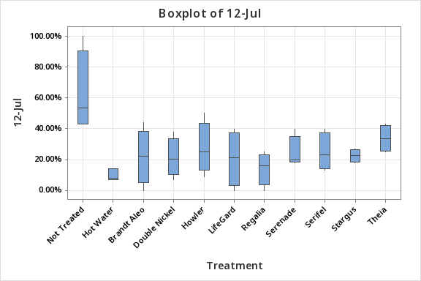
A
C
BC
BC
BC
BC
BC
BC
BC
BC
BC
Disease incidence

Fig. 1. Mean bacterial spot disease incidence rated at the end of the experiment (trial 1). Treatments that do not share a letter are significantly different (P=0.006, Fisher’s least significant difference test).

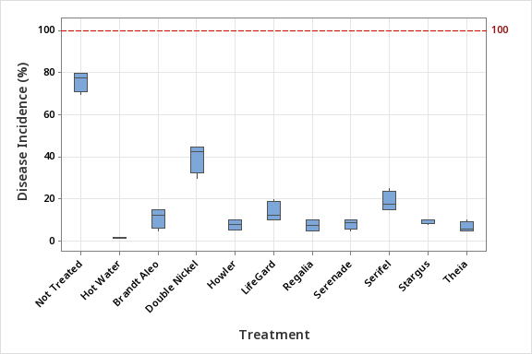
A
B
C
DE
CD
DE
DE
E
F
EF
EF

Fig. 2. Mean bacterial spot disease incidence rated at the end of the experiment (trial 2). Treatments that do not share a letter are significantly different (P=0.006, Fisher’s least significant difference test).
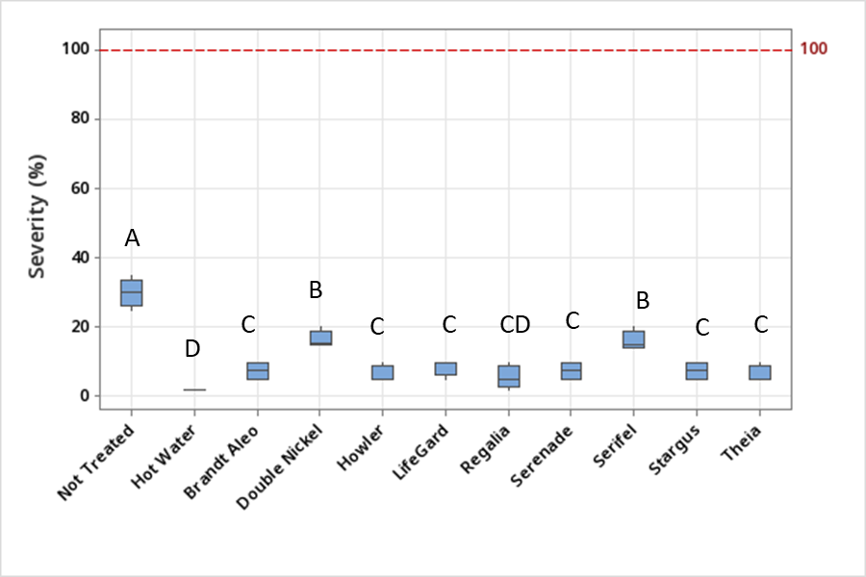
Fig. 3. Mean bacterial spot disease severity in pepper seedlings rated at the end of the experiment (trial 2). Treatments that do not share a letter are significantly different (P<0.0001, Fisher’s least significant difference test).

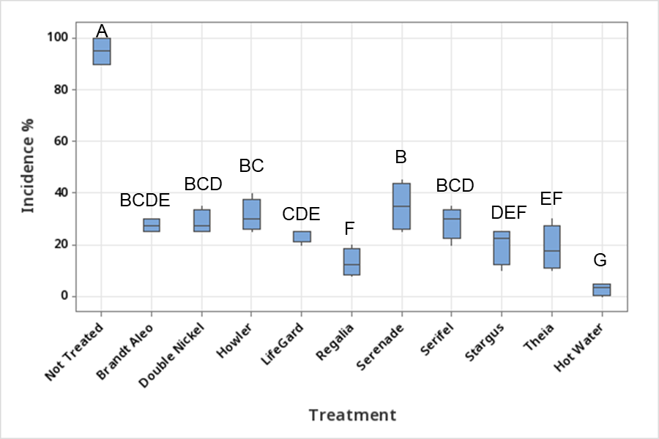
Fig.4. Mean Pseudomonas leaf spot disease incidence in pepper seedlings rated at the end of the experiment (November-December trial). Treatments that do not share a letter are significantly different (P<0.0001, Fisher’s least significant difference test).

