**Ohio Vegetable & Small Fruit Research & Development Program**

**Final Report**

**2022**

**Project Title:** Seed and Seedling Treatments to Manage Bacterial Spot in Peppers

**Principle Investigator(s)**: Sally A. Miller and Francesca Rotondo

**Phone Number**: 330-466-5249 (mobile)

**Fax**: 330-263-3841

**E-mail:** miller.769@osu.edu; [rotondo.11@osu.edu](mailto:rotondo.11@osu.edu)

**Cooperating Institution**: The Ohio State University

**Mailing Address**: Department of Plant Pathology, 1680 Madison Ave., Wooster, OH 44691

**Other Key Personnel**: Josh Amrhein, and Raven Schaffter, OSU

**Why was this project funded?** We have data from previous work as well as anecdotal evidence from growers that sanitizing seed treatment with hot water or dilute bleach eliminates *Xanthomonas* spp. from pepper seeds. However, these sanitizing seed treatments are not widely adopted in Ohio due to perceived complexity, concerns about damage to seeds, and incompatibility with seed add-ons such as priming, pelleting and pesticide applications. We will evaluate the efficacy of biological products as well as nanoparticles in suppressing or eliminating *Xanthomonas* populations on pepper seeds. The second most critical point to manage bacterial spot in peppers is during transplant production in the greenhouse. We will utilize our standard protocol to assess the effects of treatments on reducing or eliminating the spread of bacterial spot from a known source of inoculum.

**Part I: Suppression of *Xanthomonas* on pepper seeds**

**Project outline**: The efficacy of biological products against bacterial leaf spot (*Xanthomonas euvesicatoria*) on artificially infested pepper seeds (cultivar California Wonder) was evaluated in a greenhouse experiment. The biologicals Howler, Theia, Serenade, Stargus, and Regalia were applied as seed treatments and evaluated in a greenhouse experiment, with a completely randomized block design. Seeds were artificially infested by vacuum infiltration using a bacterial suspension (1010 CFU/ml). The *X. euvesicatoria* strain (SM215-20) utilized to infest the seeds was a moderately copper-resistant strain (resistant to 100 ug/ml copper sulfate). Seed infestation was assessed by plating 25 seeds on Yeast Dextrose Calcium Carbonate medium plates (four reps). The incidence of infested seeds was 80%. Seed treatments were applied at a concentration of 109CFU/ml of the active ingredient per gram of seeds. Howler was applied at a lower concentration because of its formulation (106 CFU/ml) (Table 1). Regalia, a plant extract, was applied as a water-based slurry (1:1 ratio water/bioproduct). The hot water treatment (commercial standard) was applied at 37°C for 10 minutes, 51°C for 30 minutes, and cold water for 5 minutes. Treatments were applied through priming drum methodology (incubation period: 5 days, temperature: 24°C, rotatory speed: 30 cm/min, moisture content: 39%). Seeds were planted in Baccto soil potting mix, and efficacy was determined using a grow out assay. Symptom development was monitored, and bacterial spot disease incidence and severity were rated weekly.

Table 1. Application rates of the seed treatments.

|  |  |  |  |
| --- | --- | --- | --- |
| **Treatment** | **Manufacturer** | **Active ingredient** | **Rate** |
| LifeGard WG | Certis | *Bacillus mycoides* isolate J | 3x109 CFU/g |
| Stargus | Marrone BioInnovations/Pro Farm Group | *Bacillus amyloliquefaciens* strain F727 | 1 X 109 CFU/g |
| Regalia | Marrone BioInnovations/Pro Farm Group | Giant knotweed extract | 1:1 product:water |
| Serenade ASO | Bayer Crop Science | *Bacillus subtilis* strain QST 713 | 1.04 × 109 CFU/g |
| Theia | AgBiome | *Bacillus subtilis* strain AFS032321† | 1.0 x 109 CFU/g |
| Howler | AgBiome | *Pseudomonas chlororaphis* strain AFS009† | 1.0 X 106 CFU/g |
| Hot water (standard) | - | - | - |

**Take-home messages**: Hot water sanitation of pepper seeds remains the most effective control for bacterial seedborne disease. However, some of the treatments (Regalia, Theia and Howler) decreased the *Xanthomonas* bacterial inoculum on the seeds. Some of the products tested were not suitable for seed treatment. Different methodologies for seed treatment will be considered and further tested.

**Impacts:** One or more of the biological products tested may sufficiently reduce *Xanthomonas* inoculum on seeds to be part of an integrated disease management strategy. For this experiment, seeds were heavily infested with *X. euvesicatoria* (80% of seeds were infested), which is far above the infestation level in a contaminated commercial seed lot. The degree of *Xanthomonas* suppression observed with Regalia, Theia, and Howler may be adequate to prevent significant bacterial spot development in seedlings in the greenhouse and later in the field. It is very likely that these treatments will be effective against other bacterial and fungal pathogens of peppers and other vegetables.

**What was discovered?** The plating assay showed that the incidence of *X. euvesicatoria*-infested seeds before application of the biologicals was 80%. LifeGard, Stargus and Serenade reduced seed germination (10% germination), therefore these treatments were not further evaluated in the grow out assay. The hot water treatment (standard) was the most effective, with no disease observed in the grow out assay. Regalia, Howler and Theia significantly reduced disease incidence by 55%, 48% and 45%, respectively, compared to the non-treated control (Fig. 1A). Mean disease severity rating ranged from 0 (hot water treated seeds) to 11% (infested non-treated seeds). Regalia decreased disease severity by 66%, while both Theia and Howler decreased disease severity by 55% (Fig 1B). The efficacy of Regalia, Howler and Theia in suppressing *Xanthomonas* on pepper seeds was statistically similar.

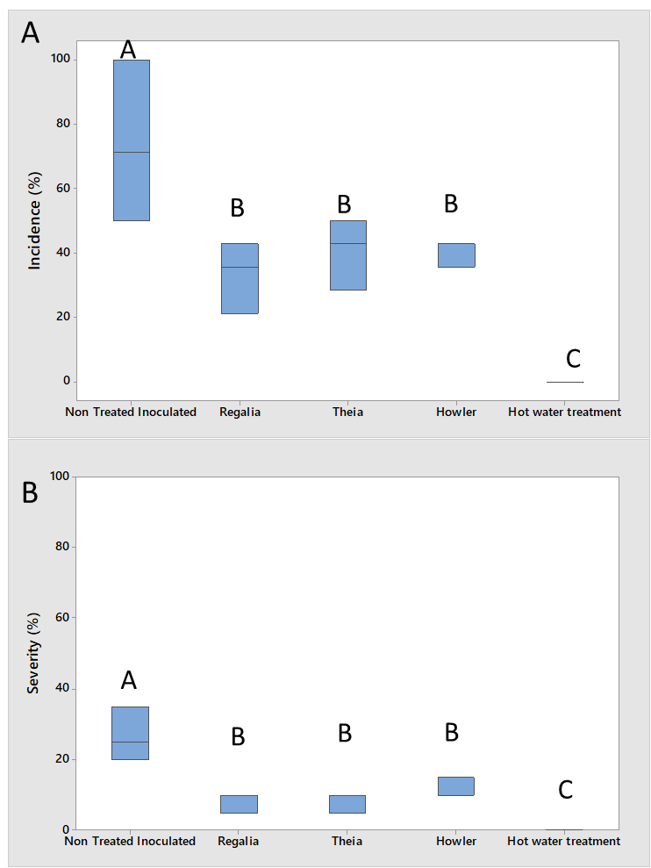

Fig.1. Mean bacterial spot disease incidence (A) and severity (B) rated at the end of the experiment. Treatments that do not share a letter are significantly different (P=0.004, Fisher’s least significant difference test).

**Part II: Biologicals and Zinkicide against bacterial spot as seedling treatments**

**Project outline**: California Wonder pepper seeds were seeded in Baccto soilless potting mix on November 1, 2022. The experiment was conducted in a greenhouse with a complete randomized block design. Biological, Zinkicide and commercial standard (Table 2) applications were started at the seedling stage (two true leaves formed). The first application was performed before the inoculation of *Xanthomonas euvesicatoria* SM215-20 at 108 CFU/ml. Applications of the products were repeated weekly. Disease severity (%) was scored weekly.

Table 2. List of seedling treatments and their application rates.

|  |  |  |  |
| --- | --- | --- | --- |
| **Treatment** | **Manufacturer** | **Active ingredient** | **Rate** |
| Serenade ASO | Bayer Crop Science | *Bacillus subtilis* strain QST 713 | 1gal/A |
| Serifel | BASF | *Bacillus amyloliquefaciens* strain MBI600 | 16oz/A |
| LifeGard WG | Certis | *Bacillus mycoides* isolate J | 4.5oz/100gal |
| Stargus | Marrone BioInnovations/Pro Farm Group | *Bacillus amyloliquefaciens* strain F727 | 1fl oz/gal |
| Regalia | Marrone BioInnovations/Pro Farm Group | Giant knotweed extract | 1 gal/A |
| Brandt Organics Aleo | Brandt | Garlic oil | 12floz/A |
| Kocide 3000-O (standard) | Certis | Copper hydroxide | 1.25 lb/A |
| Theia | AgBiome | *Bacillus subtilis* strain AFS032321† | 2lb/A |
| Howler | AgBiome | *Pseudomonas chlororaphis* strain AFS009† | 5lb/A |
| Zinkicide | Not yet commercial | Zinc oxide-based nanomaterial | 2qt/A |
| Non-treated infested | - | - | - |
| Non-treated non-infested | - | - | - |

**Take-home messages**: Seven of nine products tested performed as well against bacterial spot of peppers as the commercial standard, Kocide 3000-O, but none outperformed the standard. Disease severity was low-moderate in this experiment, possibly due to a degree of resistance to bacterial spot in the pepper variety used. California Wonder is reported by some seed companies as resistant to bacterial spot This trial showed that the use of partially resistant pepper varieties and application of bioproducts during transplant production are effective tactics to manage these bacterial diseases. The experiment will be repeated utilizing a pepper variety (Paladin) fully susceptible to bacterial spot.

**Impacts:** More research is needed, but it is likely that one or more of the products tested on seedlings can be used in conjunction with biological seed treatment to suppress bacterial spot development in pepper seedlings during transplant production, reducing the chance that epidemics of the disease will happen in the field.

**What was discovered?** All the bioproducts, Zinkicide, and the commercial standard decreased bacterial spot disease severity compared to the inoculated, non-treated control (Fig.2). The highest value of disease severity recorded was 25% (inoculated non-treated control). Kocide 3000-O (commercial standard) and LifeGard were the numerically best performing treatments with disease severity reductions of 77% and 82%, respectively. However, the reduction was statistically similar for Kocide 3000-O, LifeGard, Brandt Organic Aleo, Serifel, Stargus, Theia and Zinkicide. Regalia and Howler caused the lowest reduction of disease severity (47%) (Fig.2).

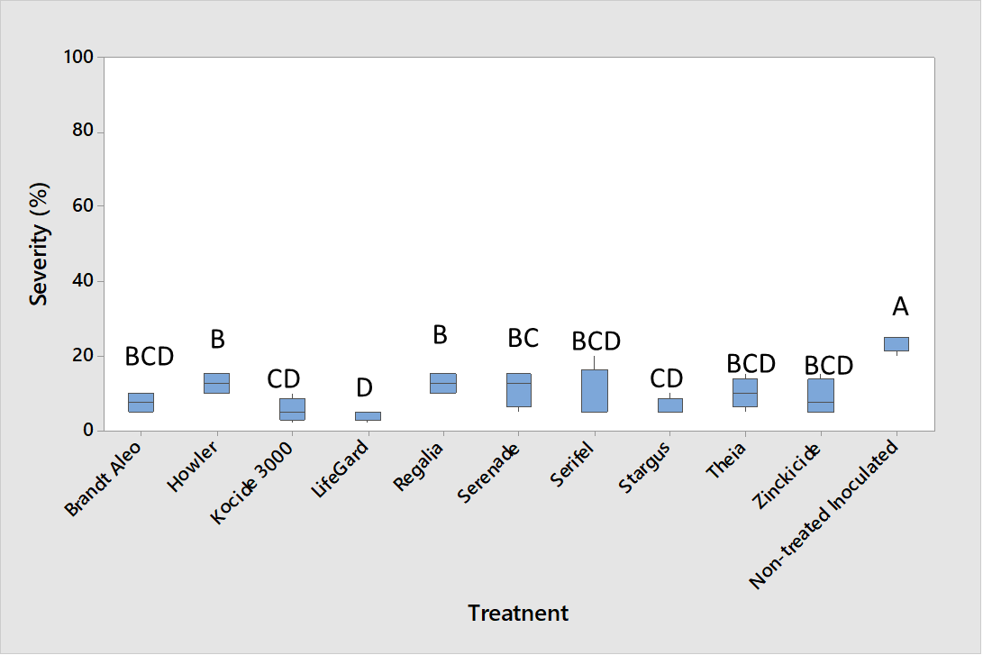

Fig.2. Mean bacterial spot disease severity in pepper seedlings rated at the end of the experiment.

Treatments that do not share a letter are significantly different (P<0.0001, Fisher’s least significant difference test).