Project Title: Early Detection of Downy Mildew in Blackberry
Principal Investigators: Melanie L. Lewis Ivey
Phone Number: 330-263-3838 (Dept. Plant Pathology Office)
E-mail: ivey.14@osu.edu
Cooperating Institution: The Ohio State University (CFAES-Wooster), Department of Plant Pathology
Mailing Address: 1680 Madison Ave., Wooster, OH 44691
Other Key Personnel: Therese Miller, The Ohio State University (CFAES-Wooster), Department of Plant

Note: In the interim report, the January and March samples were erroneously mixed up. The error has been corrected for this final.

Why was this project funded? Downy mildew, caused by Peronospora sparsa, is a systemic disease of blackberry (Rubus sp.) that was first observed in Ohio in 2017. Symptoms first appear on the dense foliage near the base of the plants during cool, wet conditions. The primary source of the pathogen is transplants or cuttings. Since the disease does not develop until conditions are cool and humid, plants that appear to be healthy could be systemically infected. Currently there is no clean plant certification for blackberry downy mildew. Funding for this project supported determining best practices for sampling and detecting P. sparsa in asymptomatic nursery plants.

Project outline.
Asymptomatic nursery plants (3 cultivars X 10 plants/cultivar) were purchased from a regional nursery and maintained as nursery stock in Wooster, Ohio. Plants were maintained in a greenhouse until June and then moved outdoors to promote flowering. Plants were not inoculated. Roots, stems (cane), and mature and immature leaves were collected three times (January-early vegetative, March- vegetative, and August- flowering/fruit set), DNA was extracted from the samples, and P. sparsa specific PCR was conducted.

Take-home messages.
The nursery plants tested in this study were systemically infected with P. sparsa. At the time the plants arrived from the nursery in January, 90%, 40%, and 100% of the ‘Caddo’, ‘Natchez’, and ‘Ouachita’ plants tested positive for P. sparsa. P. sparsa was detected most frequently in new or immature leaves, followed by mature leaves, roots, and stems. Based on these findings growers should assume that downy mildew susceptible varieties such as ‘Caddo’ and ‘Ouachita’ nursery plants are infected with P. sparsa and that preventative spray programs should be implemented as soon as the first symptoms of the disease are observed.

Impacts.
Through this study a sampling and detection protocol for P. sparsa in blackberry nursery plants was established. This protocol can be adopted by plant disease diagnostic clinics in the state for rapid confirmation of the presence of P. sparsa in blackberry.

What was discovered?
Except for ‘Natchez’, P. sparsa was detected most frequently in leaves at all three sampling times (Figure 1). ‘Natchez’ is less susceptible to downy mildew and P. sparsa was detected less frequently in all tissue types. There was no obvious trend in the frequency of detection of P. sparsa between immature or mature leaves (Figure 2). However, in March, when the plants were vigorously putting on new leaves, P. sparsa was more frequently detected in immature leaves. Independent of variety and tissue type, P. sparsa was detected more frequently in January, when plants were breaking dormancy and new leaves were emerging, than in March or August (Figure 3). Of the thirty plants tested, only one plant (cv. Natchez; plant 15) tested negative in all sample types and at each sampling time (Figure 4). The remaining plants tested positive at least once.

Figure 1. Frequency (number of plants, X-axis) of Peronospora sparsa detected by polymerase chain reaction (PCR) in blackberry roots, stems (canes), and leaves over a production season. Ten plants per variety were tested. Root samples were not collected in March.

Figure 2. Frequency (number of plants, X-axis) of Peronospora sparsa detected by polymerase chain reaction (PCR) in immature and mature blackberry leaves over a production season. Ten plants per variety were tested.

Figure 3. Percent of plants (X-axis) of Peronospora sparsa detected by polymerase chain reaction (PCR) in blackberry roots, stems (canes), and immature and mature leaves over a production season. Thirty plants (n=30) per tissue type. Roots were not collected in March.

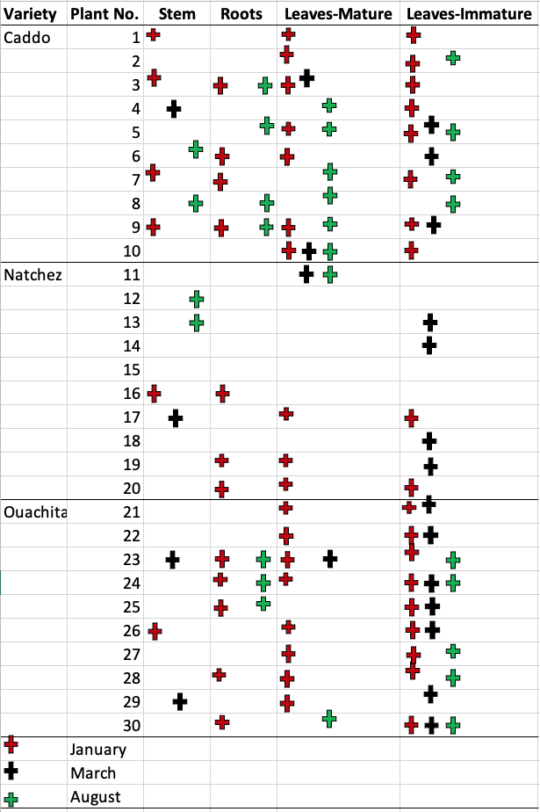
Figure 4. Detection (positive or negative) of Peronospora sparsa in nursery plants (n=10) in January (red), March (black), and August (green). Roots were not collected in March.

