**Ohio Vegetable & Small Fruit Research & Development Program**

**Final Report**

**2017**

**Project Title:** Anaerobic Soil Disinfestation to Manage Plant Pathogens in Muck Soils

**Principle Investigator(s)**: Sally A. Miller

**Phone Number**: 330-263-3678

**Fax**: 330-263-3841

**E-mail**: miller.769@osu.edu

**Cooperating Institution**: The Ohio State University (OARDC) Department of Plant Pathology

**Mailing Address**: 1680 Madison Ave., Wooster, OH 44691

**Other Key Personnel**: Anna Testen, Jhony Mera, Francesca Rotondo, The Ohio State University - OARDC

The objective of this project was to determine the efficacy of anaerobic soil disinfestation (ASD) as a soilborne disease management strategy for muck vegetable production. Anaerobic soil disinfestation consists of amending soil with a carbon source, irrigating soil to saturation, and then covering the soil with plastic mulch for several weeks. This disease management strategy had not been studied in muck vegetable production systems until 2016 when OVSFRDP funded the first year of this research project. The trials conducted in 2017 represent a second year of field data for these muck ASD field trials.

Two trials were conducted in June-October 2017. We examined the effects of ASD against clubroot (*Plasmodiophora brassicae*) on mustard at the OARDC Muck Crops Agricultural Research Station in Willard, OH and against the northern root knot nematode *(Meloidogyne hapla*) on lettuce at a commercial farm in Stark County, OH. Trials were laid as a randomized complete block design with five replicates with plots that were 3 ft by 10 ft with a 10 ft buffer within rows and 3 ft buffer between rows. The treatments were: wheat bran (9 t/a), molasses (4.5 t/a), wheat bran (9 t/a) plus molasses (4.5 t/a), an uncovered, non-amended control, and a covered, non-amended control. The covered control was added to the 2017 trials to account for possible solarization effects. Wheat bran was spread by hand and incorporated to a depth of 6-8 inches using a tractor drawn rototiller. Molasses was applied using watering cans. Soils were then irrigated to saturation and covered with black plastic mulch. The ASD treatment lasted four weeks. Soil temperatures were recorded during the experiment and reducing conditions (an indicator of anaerobic conditions) were measured using IRIS tubes. Soil was collected after ASD treatments from each treatment for studies at OARDC.

Lettuce ‘Laredo’ or mustard ‘Southern Curled’ was direct sown in the experimental area 7-10 days following removal of plastic mulch from the treated areas. Plants were harvested 7 weeks (mustard) or 10 weeks (lettuce) after planting and evaluated for yield and disease.

Clubroot severity was assessed on mustard greens roots using a 0-3 scale for 25 plants from each field plot, and these severity ratings were used to calculate a clubroot disease index for each plot (n equals the number of plants with a given rating):

$$Clubroot disease index= \frac{\sum{(nx0 + nx1 + nx2 + nx3)}}{Number of plants x 3} x 100$$

The same rating scale was used to assess roots from the post-ASD bioassay. Root knot nematode galls were counted on each lettuce root system.

Post-ASD Bioassay

A post-ASD bioassay was conducted at OARDC to determine if ASD treatments affected soil pathogens and plant growth. Soils collected following the ASD treatment in the field (both locations) were used in this study. In each study, five pots were filled with soil from one of the five treatments. Lettuce ‘Tropicana’ or mustard greens ‘Southern Curled’ were planted in pots and grown in controlled conditions in a growth chamber. Plants were harvested after 7 weeks for mustard and 8 weeks for lettuce and evaluated for yield and disease.

Results

*Average soil temperatures*

Soil temperatures were elevated in all ASD treatments, and these temperatures were 2-7° cooler than the ASD trials in 2016.

|  |  |  |
| --- | --- | --- |
|  | Muck Research Station | Stark County |
| Wheat bran | Probe failure | 80.8° F |
| Molasses | 77.2° F | 79.3° F |
| Wheat bran and molasses | 77.5° F | 81.9° F |
| Non-amended, uncovered | 74.5° F | 73.6° F |
| Non-amended, covered | 76.3° F | 76.8° F |

*IRIS tubes*

In anaerobic soils, reducing conditions develop due to a lack of oxygen. Under reducing conditions, microbes cannot use oxygen to generate energy and must switch to alternative compounds, such as iron, to generate energy. To measure these reducing conditions in our treatments, we used IRIS (“Indicator of Reduction In Soils”) tubes. IRIS tubes are PVC pipes painted with an iron oxide (“rust”) paint. Microbes use the iron in iron oxide paint to generate energy under anaerobic conditions, so anaerobic conditions are indicated by paint removal (less paint equals more reduction). The amount of paint missing can be quantified and used to estimate the degree of reducing conditions in the soil. Significantly higher levels of paint loss were observed for IRIS tubes placed in ASD-treated soils compared to both non-amended control soils in both trials. Levels of paint reduction in wheat bran and wheat bran plus molasses treatments were significantly higher than in the molasses treatment and non-amended controls in both trials. There were higher levels of soil reducing conditions at the Muck Crops Research Station and lower levels of reducing conditions than at the research site in Stark County compared to the 2016 trials. For all graphs, means sharing the same letter do not differ significantly based on Tukey’s HSD with a family-wise error rate of α = 0.05. 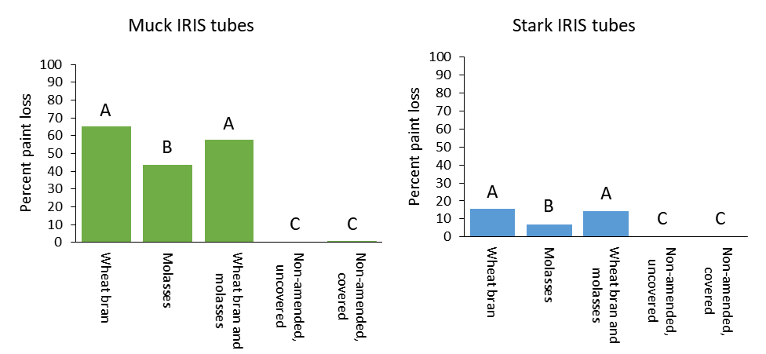

*Field results: Yield*

Dry biomass of mustard plants (tops) grown in plots treated with ASD using wheat bran and wheat bran plus molasses was significantly higher than for plants in plots amended with molasses. The dry biomass of mustard plants grown in plots amended with wheat bran or wheat bran plus molasses were nearly twice the biomass of plants grown in plots of either of the non-amended controls. The fresh biomass of lettuce plants grown in grown in non-amended, covered control plots was significantly lower than plants grown in plots amended with wheat bran plus molasses. There were no other significant differences in lettuce biomass.

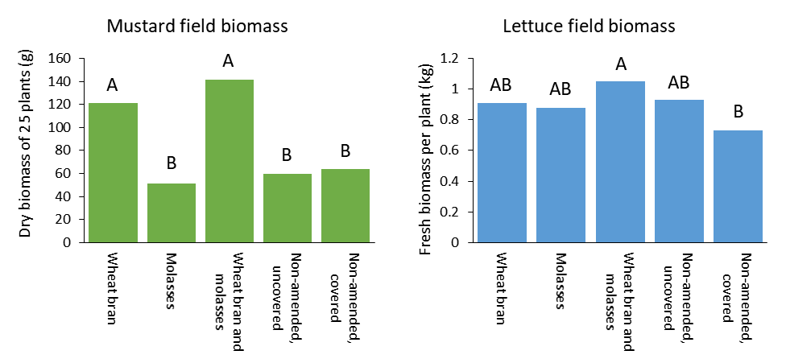

*Field results: Disease*

There was a significantly lower clubroot disease index for mustard plants grown in soils amended with either wheat bran or wheat bran plus molasses compared to plants grown in non-amended, uncovered control soils. The clubroot index was also significantly lower in plants grown in wheat bran plus molasses amended soils compared to plants grown in both non-amended, covered soils. For lettuce roots, ASD treatments with either wheat bran-based treatment led to significantly lower numbers of root knot nematode galls per root system compared to plants grown in either control soil. Plants grown in molasses-amended soils did not have significantly lower levels of root knot nematode galling compared to either control.

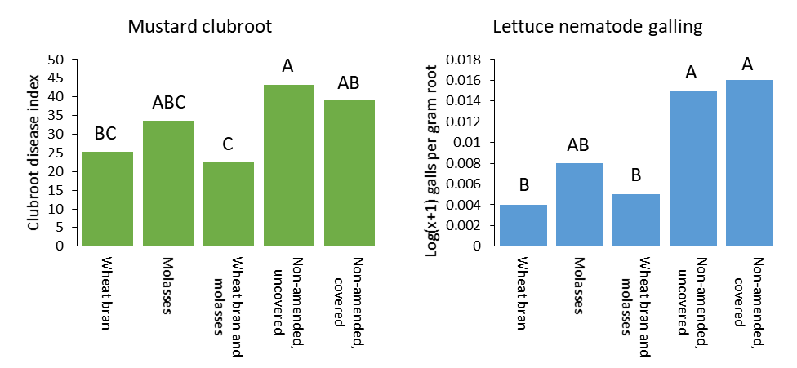

*Post ASD bioassay results: Yield*

The dry biomass of mustard and lettuce plants grown in soils amended with wheat bran or wheat bran plus molasses and subjected to ASD in the field were significantly higher than the dry biomass of plants grown in either non-amended control soils or molasses-amended soils. Data are shown from the first bioassay only.

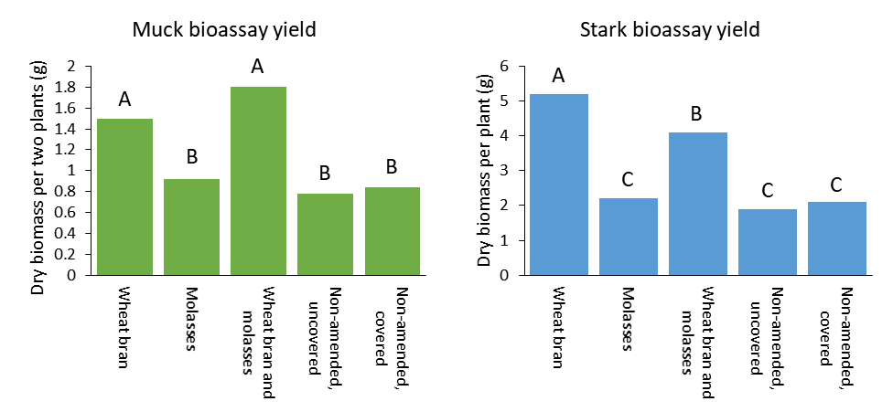

*Post ASD bioassay results: Disease*

Clubroot disease indices for mustard plants grown in all ASD field-treated soils amended with either molasses or wheat bran plus molasses were significantly lower than for mustard plants grown in non-amended, uncovered control soils. No ASD treatment significantly reduced the clubroot disease index in plants compared to plants grown in soils from the covered control. Significantly fewer nematode galls were found on roots of lettuce plants grown in soil treated with any ASD amendment compared to plants grown in non-amended control soils.

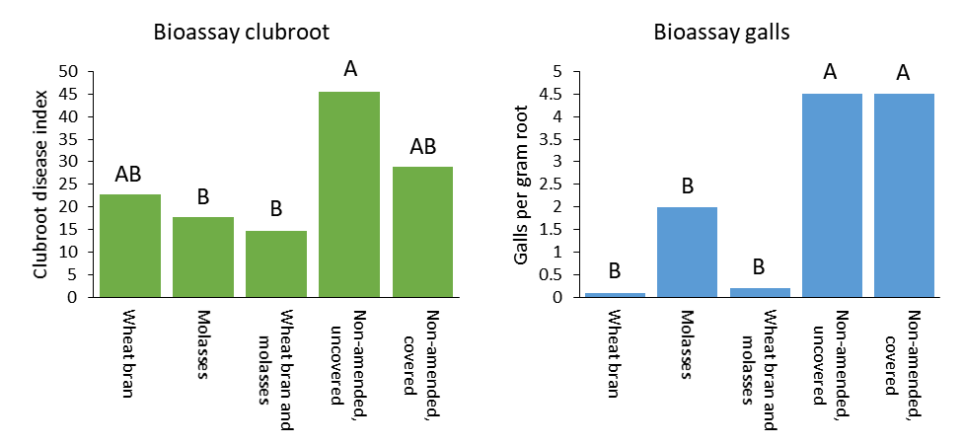

Conclusions

The trials conducted in 2017 provided a second year of field data on the efficacy of ASD as a means of managing soilborne diseases in muck soils. Results were consistently promising for use of ASD to control nematode pests in both trial years, but trial results for clubroot were more variable. Despite the variability in disease control, a significant increase in biomass (yield) was associated with wheat bran-based ASD treatments indicating another positive aspect of the ASD treatment. We did not observe any benefit to combining both wheat bran and molasses and wheat bran alone would be a suitable carbon source for muck soils. Based on the results of this study, we recommend wheat bran at a rate of 9 tons per acre as a carbon source when conducting ASD.

Future research could examine the use of alternative ASD carbon sources, such as seed meals or cover crops, for efficacy against soilborne diseases in muck soils.